Makar Sankranti

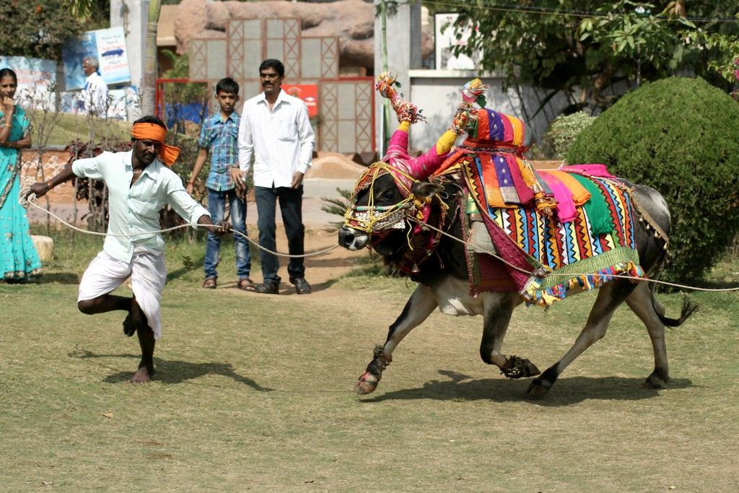

# Why Makar Sankranti is celebrated?

**Makar Sankranti is one of the most propitious days for Hindus, and is distinguished in almost all parts of India in countless cultural forms, with immense devotion, gaiety and fervor. This article deals with the Makar Sankranti festival, significance, importance, history etc.**

Why Makar Sankranti festival is celebrated?

Makar Sankranti is one of the most propitious days for the Hindus, and is distinguished in almost all parts of India in countless cultural forms, with immense devotion, gaiety and fervour. It is the main festival of Hindus and is dedicated to Lord Sun. It also refers to a specific solar day in the Hindu calendar. On this auspicious day, the sun enters the zodiac sign of Capricorn or Makar which marks the end of winter month and start of longer days. This is the beginning of the month of Magh. To recompense for the distinction that happens due to the revolution around the sun, every 80 years the day of Sankranti is deferred by one day. Makar Sankranti generally falls on January 14th. From the day of Makar Sankranti, the sun begins its northward journey or Uttarayan journey. Therefore, this festival is also known as Uttarayan.  
**History of Makar Sankranti**  
Sankranti is deemed a Deity. As per the legend Sankranti killed a devil named Sankarasur. The day next to Makar Sankrant is called Karidin or Kinkrant. On this day, Devi slayed the devil Kinkarasur.The information of Makar Sankranti is available in Panchang. The Panchang is the Hindu Almanac that provides information on the age, form, clothing, direction and movement of Sankranti.  
**Importance of Makar Sankranti**  
Makar Sankranti is the date from which Northward movement of the sun begins. The period from Karka Sankranti to Makar Sankranti is known as the Dakshinayan.

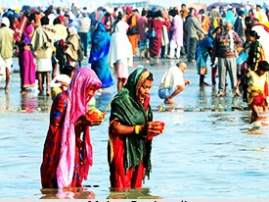  
Source: www.indianetzone.com

- According to the scriptures, Dakshinayan symbolizes as the night of god or the sign of negativity and Uttarayan is considered as a symbol of day of Gods or a sign of positivity. Since on this day sun starts its journey towards the north so, people take a holy dip in Ganga, Godavari, Krishna, Yamuna River at holy places, chant mantras etc. Normally the sun affects all the zodiac signs, but it is said that the entry of the sun in the zodiac sign of Cancer and Capricorn religiously is very fruitful.  
- Before Makar Sankranti, the sun is in the Southern Hemisphere. For this reason, in India, in winter nights are longer and days are smaller. But with the Makar Sankranti, sun starts its journey towards Northern Hemisphere and so, days will be longer and nights smaller.  
- On the occasion of Makar Sankranti, people express their gratitude towards the people of India throughout the year by worshiping the sun God in various forms. Any meritorious deeds or donation during this period establishes more fruitful.  
- Performing haldi kumkum ceremony in a way that invokes the waves of quiescent Adi - Shakti in the Universe to get triggered. This helps in generating impression of Sagun devotion on the mind of a person & enhances the Spiritual emotion to God.  
**In different regions of the country, Makar Sankranti is celebrated by different names**  
- **Lohri**: One day before Makar Sankranti, on 13th January, Lohri is celebrated in Haryana and Punjab. At night, people gather around the bonfire and throw til, puffed rice & popcorns into the flames of the bonfire. Prayers are offered to the bonfire seeking abundance & prosperity.

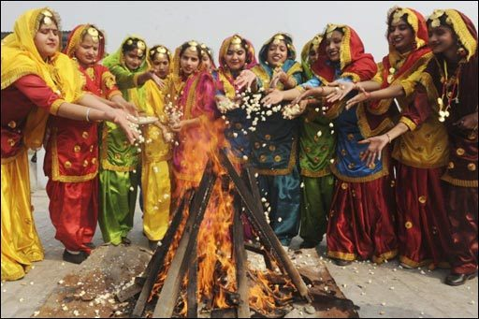  
Source: www.3.bp.blogspot.com  
-**Festival of Donation "or" Khichdi "**: In Uttar Pradesh it is mainly the festival of 'Donation'. The Magh fair, which continues for one month on the confluence of Ganga, Yamuna and Saraswati in Allahabad, starts from the day of Makar Sankranti only. On this auspicious day people do fast in Uttar Pradesh eat and offer khichdi. Also, Khichdi Mela is organized at Gorakhdham in Gorakhpur.  
- In **Bihar**, Makar Sankranti festival is known as Khichdi. On this day, donating urad, rice, gold, woollen clothes, blankets etc. have their own importance.  
- In **Maharashtra**, all married women donate cotton, oil and salt to other suhagin or married women on their first Sankrant.  
- In **Benga**l, there is a tradition of donating til after taking bath in Makar Sankrant. Huge fair is also organised every year in Gangasagar.  
- **Pongal:** On the occasion of Makar Sankranti in Tamil Nadu, this festival is celebrated as Pongal for four days.  
- **Kite Festival:** In Gujarat, the kite festival is organized on the occasion of Makar Sankranti.  
Therefore, in India, Makar Sankranti festival has its own importance. It is celebrated in various States by different names.  What is its history, why Makar Sankranti is celebrated every year, etc. is also discussed in the above article.